**User Manual**

**Made By**

**Leonardo Drici** (1905444)

Sommario

**Layout** 3

**List section** 3

**Add section** 4

**Sell section** 5

**Update Section** 6

**Remove Section** 7

**Extra features** 7

**Always saving** 7

**Save to CSV** 7

**Clear all** 8

# **Layout**

This software is split into various section which help the user to understand more how the software works. Each section involves a specific feature and is defined in its own panel.

## **List section**

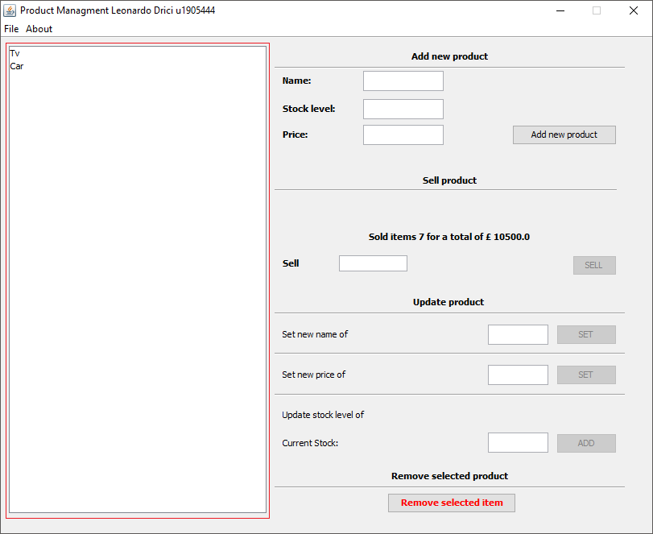

Figure List Section

This section enables the user to see all the products present in the system allowing them to see which products are present on the system at all time. When one product is selected the user can perform a set of functions on it such as sell it or update its details.

## **Add section**

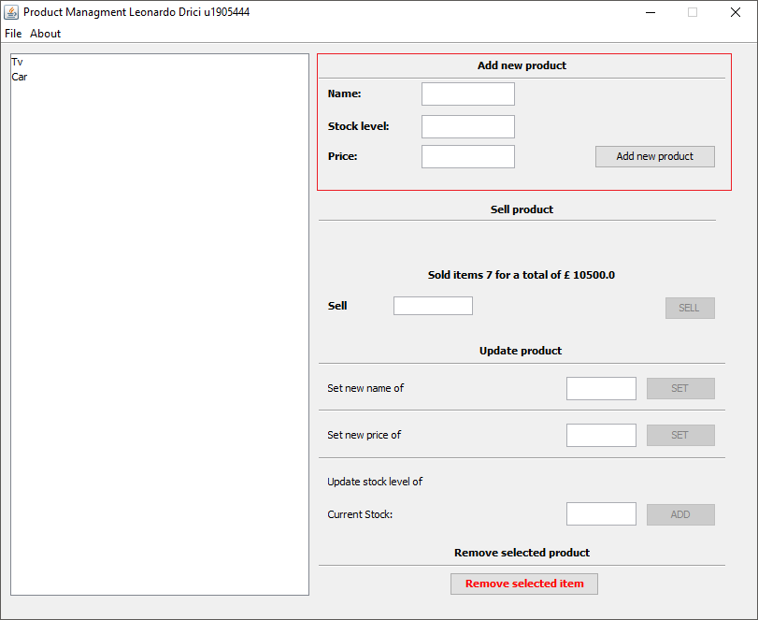

Figure Add section

This section of the software enables the user to add new products. The user as to fill all the text fields and press the add new product button. If any of the field is not completed the program will prompt the user with an error message that will notify them where they have mistaken.

## **Sell section**

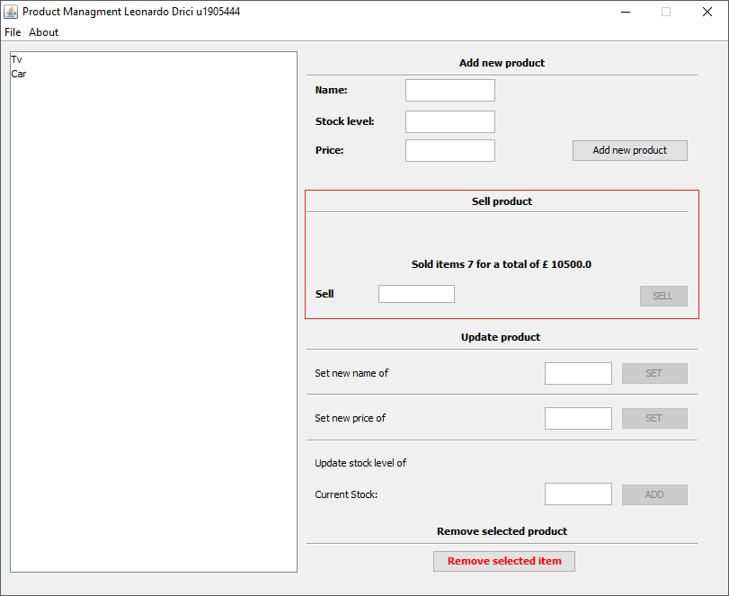

Figure Sell Section

With this section the user is able to sell the products, this action can be done when the text field is completed and the Sell button is clicked, if the field doesn’t contain a number, its empty, or the value is over the available stock count the user will get prompted with the appropriate error message.

## **Update Section**

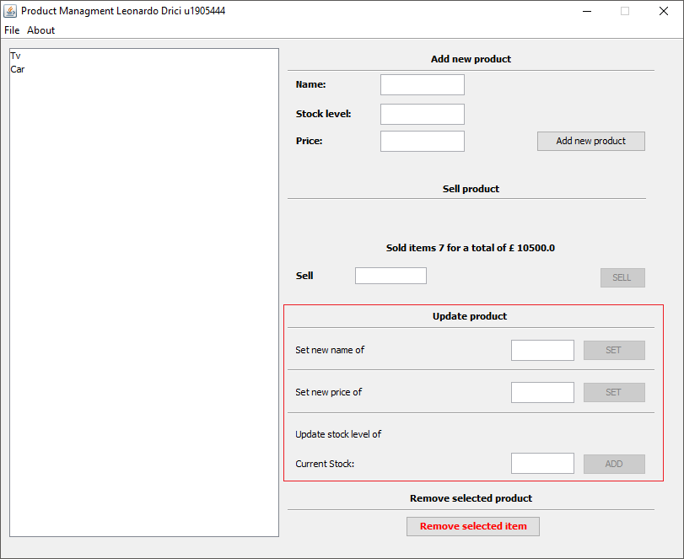

Figure Update Section

The user can use this section to update any information regarding the selected product on the list. They have the option to update the name, the price and the stock count of the selected product. Each action can be done with their appropriate text field and button. If the information given is not correct the user will be prompted with the appropriate error message.

## **Remove Section**

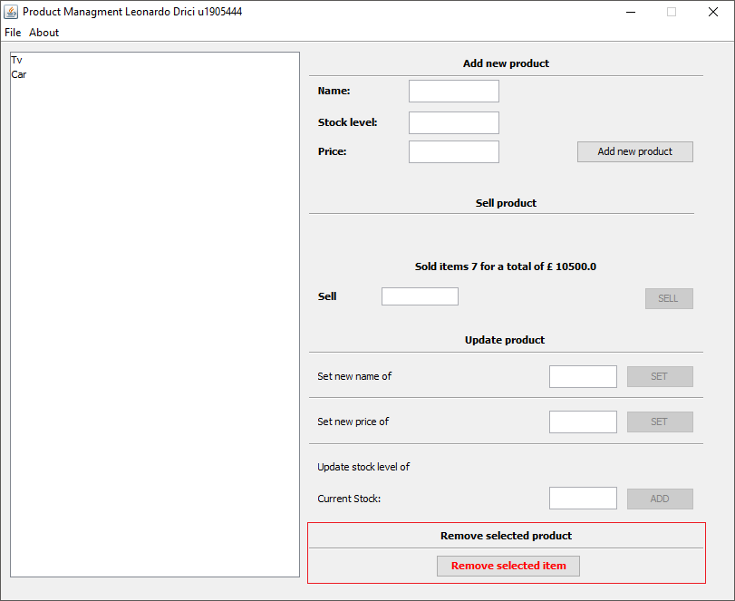

Figure Remove Section

This section allows the user to delete the product selected, if the button gets clicked the user will be prompted with a confirmation message and if the user presses yes the item will be deleted.

# **Extra features**

The software also provides some extra that give the user a smother experience when using the software.

## **Always saving**

The software will always save when it gets closed by doing so the next time the software will get opened it will resume from the last status.

## **Save to CSV**

The user can save the current status of the products to a csv file, enabling them to perform any other task that the software doesn’t allow. This function can be accessed by clicking File -> Save to file.

## **Clear all**

This feature allows the user to clear all the products in the list, the user will get promoted with a confirmation message before continuing with the action. This feature can be accessed by clicking File -> Clear All.